VISVESVARAYA TECHNOLOGICAL UNIVERSITY
JNANA SANGAMA, BELAGAVI- 590 018


MINI PROJECT REPORT(BCG586)
ON
RSA Encryption and Decryption

Submitted in Partial Fulfillment for the Award of Degree of
Bachelor of Engineering
in
COMPUTER SCIENCE AND DESIGN

Submitted by

NAME1:Kiran Kumar N ANAME2:Santhosh S M

USN1:1MP22CG026 USN2:1MP22CG048

NAME3:Tharun K L NAME4:Jagadish kumar N

USN3:1MP22CG057 USN4:1MP23CG401

Department of Computer Science And Design



Department of Computer Science And Design
MINI PROJECT (BCG586)

CERTIFICATE

This is to certify that the Mini Project (BCG586) TitledData Encryption and Decryption Toolhas been successfully carried out by Kiran Kumar N A, Santhosh S M, Tharun K L, Jagadish Kumar N bonafide students of BGS College of Engineering and Technology in partial fulfillment of the requirements for the award of degree of Bachelor of Engineering in Dept. of Computer Science and Design of Visvesvaraya Technological University, Belagavi during 2022-2026. It is certified that all corrections/suggestions indicated for Internal Assessment have been incorporated in the report. The Mini Project (BCG586)report has been approved as it satisfies the academic requirements in respect of Mini Project for the said degree.

Dr. Chandrakala H L Dr.Madhu Patil Dr.RaviKumar GK
Asst. professor , CSD HoD, CSD Principal
BGSCET BGSCETBGSCET



We Kiran Kumar N A, Santhosh S M, Tharun K L, Jagadish Kumar N bearing the USN:1MP22CG026, 1MP22CG048, 1MP22CG057, 1MP23CG401 ,students of Bachelor of Engineering in Dept. of Computer Science and Design at BGS College of Engineering and Technology, Bengaluru, hereby declare that the Mini Project (BCG586)work has been carried out by us under the supervision and guidance of Department Staff Coordinators submitted by me as a partial fulfillment for the award of Bachelor of Engineering degree in Computer Science and Design from Visvesvaraya Technological University, Belagavi during 2024-25. I also declare that, this work has not been submitted previously for the award of any degree or diploma, by me, to any institution.

Signatures

CONTENTS

Abstract

Acknowledgements

List Of Figures

1.Introduction

  - Introduction on topics
  - Motivation
  - Problem Statement
  - Objectives
  - Outline

2.Review of Literature

3. Implementation

  - Methodologies and Algorithms Used

4. Design

4.1 Software Model with use case sequence/ Data Flow Diagram

5. Testing-Test Cases

6. Results

7. Conclusion and Scope for Future Work

7.1 Summary of Contributions
7.2 Limitations and Scope for Improvement

Bibiliography

IEEE paper

ABSTRACT

The Data Encryption and Decryption Tool employs a hybrid cryptographic approach using AES and RSA algorithms to secure sensitive data. AES (Advanced Encryption Standard) is used for fast and efficient encryption of large data sets like files and images, while RSA (Rivest-Shamir-Adleman) ensures secure keys exchange. The tool is specifically designed for applications such as file, text, and picture encryption and decryption, making it versatile for various industries. It supports multiple data formats, providing robust protection for documents, images, and text messages. With its intuitive interface, users can easily encrypt and decrypt data, ensuring high-level confidentiality. This is ideal for securing personal, corporate, or sensitive information, complying with data protection standards, and is suitable for fields such as finance, healthcare, and secure communications.

ACKNOWLEDGEMENT

We take this opportunity to express our heartfelt gratitude to everyone who supported and guided us throughout the successful completion of our mini-project.

We are profoundly grateful to Sri AdichunchanagiriShikshana Trust (R.) for their invaluable assistance, unwavering cooperation, and encouragement in this research endeavour, all made possible by the divine blessings of Jagadguru PadmabhushanSriSriSriDr.Balagangadharanatha Maha Swamiji and under the spiritual guidance of Jagadguru SriSriSriDr.Nirmalanandanatha Maha Swamiji.

We are profoundly thankful to Dr. G T Raju, Director of BGS College of Engineering and Technology, for the unwavering support, providing us with the necessary facilities to execute our work successfully.

We would like to express our sincere thanks to and Dr. Ravi Kumar G K, Principal of BGS College of Engineering and Technology, for providing us with an excellent academic environment and access to resources that enabled us to carry out this project effectively.

We extend our deep gratitude to Dr. Madhu Patil , Head of the Department of Computer Science And Design in shaping our project.

Lastly, we owe our deepest appreciation to our project guide,Dr Chandrakala HL, [Asst. professor] for her invaluable guidance, mentorship, and constructive feedback throughout the project. Their expertise and continuous support motivated us to overcome challenges and achieve our objectives.

We are also grateful to all faculty members, our peers, and our families for their encouragement and moral support throughout this journey. Thank you all for making this project a memorable and enriching experience.

Student Names
1.Kiran Kumar N A
2. Shanthosh S M
3.Tharun K L
4.Jagadish Kumar N

LIST OF FIGURES

Figure Number | Figure Name
4.1 | Data flow diagram of RSA Algorithm
6.1 | HTML Code of encryption and decryption using RSA Algorithm
6.2 | Resultant View of RSA Encryption & Decryption
6.3 | When We Encrypt the Data using RSA Algorithm
6.4 | When We Decrypt the Data using RSA Algorithm

CHAPTER 1

INTRODUCTION

  - Introduction On Topics

The RSA algorithm, developed in 1977 by Ron Rivest, Adi Shamir, and Leonard Adleman, is an asymmetric cryptographic algorithm. It employs two keys:

- A public key for encryption
- A private key for decryption

The algorithm's security relies on the computational difficulty of factoring large composite numbers.

Mathematical basis of RSA uses principles from number theory:

- Prime Numbers: Multiplication of two large primes is straightforward, but factoring their product is computationally hard.

- Modular Arithmetic: Arithmetic performed over a modulus value.

- Euler’s Totient Function: Counts the integers up to n that are coprime ton.

Steps in RSA

- Key Generation

The RSA algorithm begins with generating public and private keys.

- Choose two large prime numbers p and q:
  - These primes should be chosen randomly and kept secret.

- Compute n:
n=p×q
n is the modulus for both the public and private keys.

- Compute Euler's Totient Function ϕ(n):
ϕ(n)=(p−1)×(q−1)
  - ϕ(n) is the count of numbers less than n that are coprime to n.

- Choose the public exponent e:
  - Select e such that 1<e<ϕ(n) and gcd(e,ϕ(n))=1.
  - Common choices for e include 3, 17, or 65537 because they are small and efficient to compute.

- Determine the private key d:
  - Calculate d, the modular multiplicative inverse of emod ϕ(n)e, such that: e×dmod ϕ(n)=1e
    - d ensures that the decryption process reverses encryption.

- Keys:
  - Public key: (e,n)
  - Private key: (d,n)

- Encryption

The sender uses the recipient's public key (e,n) to encrypt the plaintext M:

- Convert the plaintext M into an integer mmm, where 0≤m<n0
- Compute the ciphertext C: C = m^e
- Send C to the recipient.

- Decryption

The recipient uses their private key (d,n) to decrypt the ciphertext C:

- Compute the plaintext mmm: m = C^d.
- Convert mmm back to the original plaintext M.

  - Motivation

The motivation behind the RSA algorithm lies in ensuring secure communication, particularly in environments where sensitive data needs to be transmitted securely over insecure channels. RSA achieves this through public-key cryptography, a revolutionary concept that separates the encryption and decryption keys. Here's the breakdown:

Motivation for RSA

1. Need for Secure Communication:

In the digital age, data like passwords, financial transactions, and confidential messages need to be transmitted securely.

Traditional symmetric encryption systems require the sender and receiver to share the same secret key, creating a vulnerability in securely exchanging this key.

2. Public Key Cryptography:

RSA introduces public-key cryptography, where one key (public key) is used for encryption and another key (private key) is used for decryption.

This eliminates the need to share the secret key, significantly enhancing security.

3. Authentication and Integrity:

RSA not only encrypts data for confidentiality but can also be used for digital signatures, verifying the sender's identity and ensuring data integrity.

4. Scalability:

In systems like the internet, where millions of users interact, RSA enables secure communication without requiring each pair of users to exchange keys.

  - Problem Statement
The rapid growth of digital communication and networked systems presented critical challenges in ensuring secure data exchange. Traditional symmetric cryptographic methods, while effective, faced inherent limitations, particularly in key management and scalability. The RSA algorithm was developed to address these pressing issues.

A cryptographic system be developed to enable secure and scalable communication over insecure channels, addressing the challenges of key distribution, authentication, and data integrity while being practical and efficient for real-world applications?

  - Objectives

Encryption and decryption serve fundamental roles in securing data and communications. Their objectives are as follows:

- Confidentiality

- Encryption ensures that data is transformed into an unreadable format, preventing unauthorized access. Only individuals with the correct decryption key can revert the data to its original form and understand its content.

- Decryption allows authorized recipients to convert the encrypted data back into a readable format, preserving the confidentiality of the information during transmission or storage.

- Integrity

- Through encryption, the integrity of the data is protected. If the data is altered during transmission (e.g., due to tampering), decryption will fail to return the correct data, which alerts the recipient to potential changes or corruption.

- Integrity can also be ensured with methods like digital signatures, where encryption is used to verify that data has not been altered by unauthorized parties.

- Authentication

- Encryption can be used to verify the identity of the sender. For example, digital signatures are created using encryption to prove that a specific sender created the message, and the content has not been tampered.

- Decryption helps verify the authenticity of the sender, as only the recipient with the corresponding private key can decrypt a message that was encrypted using the sender’s public key.

- Non-repudiation

- This ensures that once a message has been encrypted and sent, the sender cannot deny having sent the message. With proper encryption (e.g., digital signatures), the sender’s identity is attached to the message, preventing them from later denying the action.

- Decryption allows the recipient to confirm that the message was indeed sent by the claimed sender, providing proof of the sender's actions.

- Data Security

- The primary role of encryption is to protect sensitive data from unauthorized access. This is crucial in areas like online banking, communication, cloud storage, and secure transactions.

- Decryption ensures that only the authorized parties who hold the proper key can access and use the data securely.

- Access Control

- Encryption supports access control by making data readable only by individuals or systems with the correct decryption key. This controls who has the ability to read or modify data.

- Decryption enforces this control by ensuring that only those with valid keys can access the information.

- Privacy

- Encryption ensures that personal or sensitive information remains private, such as in online communications (e.g., emails, messages), financial transactions, and other private exchanges of data.

- Decryption allows authorized individuals to retrieve and read their private data, ensuring privacy is maintained throughout the transmission process.

- Protection Against Data Breaches

- Encryption helps mitigate the risk of data breaches by ensuring that even if unauthorized access occurs (e.g., through hacking or physical theft), the data remains unreadable without the decryption key.

- Decryption ensures that only authorized individuals can access and use the data, which is particularly important when sensitive information is stored or transmitted in potentially vulnerable environments.

- Compliance with Regulations

- Many industries are required to follow strict regulations (e.g., GDPR, HIPAA, PCI-DSS) that mandate the encryption of sensitive data. This helps organizations avoid penalties for non-compliance and ensures the security of personally identifiable information (PII) or other protected data.

- Decryption allows authorized personnel to retrieve and use the data while maintaining compliance with legal and regulatory standards, ensuring the appropriate access to encrypted data is granted.

- Secure Communication

- Encryption enables secure communication between parties, such as in email, messaging apps, or VoIP calls. It ensures that the messages are not intercepted or understood by unauthorized individuals during transmission, protecting the confidentiality of the conversation.

- Decryption ensures that the intended recipient can access the message or communication securely and privately, ensuring the safety of the exchanged information in various communication channels.

  - Outline of the RSA Alogrithm

1. Key Generation

- Choose two large prime numbers (p and q): Select two large prime numbers and p and q

- Compute the Modulus (n): >n = p*q
- nwill be part of the public and private keys.

- Calculate Euler’s Totient (φ(n)): I(n) = (p-1) * (q-1).

- Compute a public exponent (d): Select an integer such that 1<e<I(n) and gcd(e,I(n))=1.

- Compute the private exponent : Compute d as the modular multiplicative inverse of e modulo I(n): d = e^-1(mod I(n)).

- Public key: (e,n)

- Private key: (d,n)

2. Encryption Process

  - Convert the plaintext message (M): Ensure M (numerical representation of the plaintext) satisfies 0<=M<n .

2.2 Compute the ciphertext (C) : Use the public key (e,n) to compute:

C \equivM^e \ (\text{mod} \ n).

3. Decryption Process

  - Decrypt the ciphertext :
          - The encrypted message C is received.

          - Use the private key (d,n) to compute:

M \equivC^d \ (\text{mod} \ n).

CHAPTER 2

REVIEW OF LITERATURE

Review of Literature on RSA Algorithm for Encryption and Decryption

The RSA algorithm, proposed by Rivest, Shamir, and Adleman in 1977, is one of the most widely studied and implemented public-key cryptosystems. Over the decades, numerous studies and analyses have been conducted on its efficiency, security, and applications in encryption and decryption. Below is a review of key literature in this domain.

1. Origin and Fundamentals of RSA

- Rivest et al. (1978) introduced the RSA algorithm, outlining its foundation in number theory and modular arithmetic. They demonstrated its applicability for secure key exchange, digital signatures, and encryption. The paper established RSA's reliance on the computational difficulty of factoring large integers.

- Key Insight: RSA's security is rooted in the infeasibility of breaking its key through brute force or factoring.

2. Performance Optimization
- Boneh and Shacham (2002): This study focused on accelerating RSA computations using the Chinese Remainder Theorem (CRT) during decryption, reducing computational overhead.

- Key Insight: CRT-based optimizations improve RSA decryption speed significantly.

- Sun et al. (2018): Investigated multi-threaded and hardware-based RSA implementations, demonstrating enhanced encryption and decryption speeds on modern processors.

- Key Insight: Hardware acceleration and parallelism improve RSA's performance in real-time applications.

3. Security Analyses

- Lenstra (1990): Explored vulnerabilities in RSA due to poor choice of primes and . The study emphasized the need for cryptographically secure random prime generation.

- Key Insight: Randomness and size of primes directly influence RSA's resilience against attacks.

- Koblitz and Menezes (2007): Reviewed advances in cryptanalysis and highlighted potential threats, including side-channel attacks, quantum computing, and padding oracle attacks.

- Key Insight: Proper implementation and padding schemes (e.g., OAEP) mitigate many practical attacks.

4. Applications of RSA

- Stallings (2017): Discussed RSA's role in securing web communications, digital certificates, and email encryption.

- Key Insight: RSA is foundational to protocols like HTTPS, TLS, and PGP.

- Goyal et al. (2020): Explored RSA's use in blockchain technology for transaction validation and digital signatures.

- Key Insight: RSA ensures trust and immutability in distributed systems.

5. RSA in Comparison with Other Algorithms

- Diffie and Hellman (1976): Highlighted RSA’s advantages over symmetric-key algorithms in key management but noted its computational intensity.

- Key Insight: RSA simplifies key distribution but is slower than AES or DES for bulk data encryption.

- ElGamal (1985): Compared RSA with the ElGamal encryption system, noting that RSA has simpler key management but is susceptible to chosen-ciphertext attacks without proper padding.

- Key Insight: RSA remains a preferred choice for digital signatures.

6. Challenges and Future Directions

- Shor (1994): Demonstrated that quantum computers could break RSA by efficiently factoring large integers.

- Key Insight: Quantum-resistant cryptosystems are essential for long-term security.

- Aggarwal et al. (2023): Discussed post-quantum cryptography and the need to transition from RSA to lattice-based algorithms.

- Key Insight: While RSA remains robust, its vulnerability to quantum computing necessitates the exploration of alternatives.

Conclusion

The RSA algorithm has been extensively studied and remains a cornerstone of modern cryptography. While its security and practicality have been enhanced over the years, challenges such as quantum computing and implementation flaws necessitate ongoing research. Despite its limitations, RSA continues to play a pivotal role in securing digital communication systems globally.

CHAPTER 3

IMPLEMENTATION

3.1 Methodologies And Algorithms Used

The RSA algorithm's methodology involves key generation, encryption, and decryption processes rooted in number theory and modular arithmetic. Its versatility and robust security make it integral to applications like secure communications, authentication, and data integrity.

Methodologies in RSA Algorithm

The RSA algorithm follows a systematic approach based on principles of number theory and modular arithmetic. Below is an outline of the key methodologies involved in RSA encryption and decryption:

1. Key Generation Methodology

This step generates the public and private keys required for encryption and decryption.

1. Prime Number Selection:

- Select two large, distinct prime numbers p and q .

- Ensure that these numbers are cryptographically secure and sufficiently large to prevent brute-force attacks.

2. Compute the Modulus (n):

- Calculate n = p*q.

- n determines the size of the key and is used in both encryption and decryption.

3. Calculate Euler’s Totient (φ(n)):

- Compute I(n)=(p-1)*(q-1)

- I(n) represents the count of numbers less than that are relatively prime to n.

4. Choose the Public Exponent (e):

- Select such that 1<e<I(n) andgcd(e,I(n))=1 .

- Common choices for are 3, 17, or 65537 for efficiency.

5.Compute the Private Exponent (d):

- Calculate as the modular multiplicative inverse of modulo I(n) :

D=e^-1(mod I(n)).

6. Output Keys:

- Public Key: (e,n).

- Private Key: (d,n).

2. Encryption Methodology

The encryption process ensures that plaintext data is transformed into secure ciphertext.

1. Convert Plaintext (M) to Numerical Form:

- Convert the plaintext message into an integer such that 0<M<n .

- This conversion may involve encoding schemes like UTF-8 or base64.

2. Encrypt Using the Public Key (e, n):

- Compute the ciphertext using the formula:

C \equivM^e \ (\text{mod} \ n).

3. Decryption Methodology

The decryption process recovers the original plaintext from the ciphertext using the private key.

1. Use the Private Key (d, n) to Decrypt Ciphertext (C):

- Compute the original message using the formula:

M \equivC^d \ (\text{mod} \ n).

2. Convert the Numerical Plaintext Back to Original Form:

- Transform the integer back into readable plaintext using the appropriate decoding scheme.

4. Security Methodology

RSA employs specific methodologies to enhance security:

1. Padding Schemes:

- Use schemes like OAEP (Optimal Asymmetric Encryption Padding) to prevent vulnerabilities like chosen-plaintext and chosen-ciphertext attacks.

2. Prime Number Validation:

- Ensure primes and are random and large enough (typically 2048 or 4096 bits) to resist factorization attacks.

3. Protection Against Side-Channel Attacks:

- Implement techniques like constant-time algorithms to protect against timing or power analysis attacks.

5. Performance Optimization

To improve the efficiency of encryption and decryption:

1. Chinese Remainder Theorem (CRT):

- Use CRT during decryption to reduce computational overhead.

- Decrypt separately using and , then combine results.

2. Efficient Public Exponent:

- Use a small, fixed value for (e.g., 65537) to accelerate encryption.

Summary

- The RSA algorithm's methodologies include:

- Key generation to create secure key pairs.

- Encryption and decryption processes for secure communication.

- Security measures like padding and prime validation to prevent attacks.

- Performance optimizations for real-world applications.

These methodologies collectively ensure RSA's robustness and reliability in securing digital communications.

Uses of RSA Algorithm

1. Data Encryption

RSA secures sensitive data during transmission by converting plaintext to ciphertext, ensuring that only the intended recipient can decrypt it using their private key.

2. Digital Signatures

RSA is used to sign messages, enabling:

Authentication: Verify the sender's identity.

Integrity: Ensure the message was not altered during transmission.

Non-repudiation: The sender cannot deny sending the message.

3. Secure Key Exchange

RSA facilitates the exchange of symmetric keys in protocols like TLS/SSL.

4. Digital Certificates

RSA underpins certificate-based authentication systems, such as X.509 certificates, which ensure trust in web communications.

5. Blockchain and Cryptocurrencies

RSA secures transactions, authenticates users, and validates the integrity of blockchain systems.

6. Email Security

RSA encrypts email content and attachments, ensuring confidentiality and authenticity.

7. Secure Software Updates

RSA verifies the authenticity of software updates by checking the digital signature of the update package.

8. E-commerce

Used to secure online payment systems by encrypting credit card details and sensitive information.

CHAPTER 4

DESIGN

4.1 Software Model with case Sequence/Data Flow Diagram

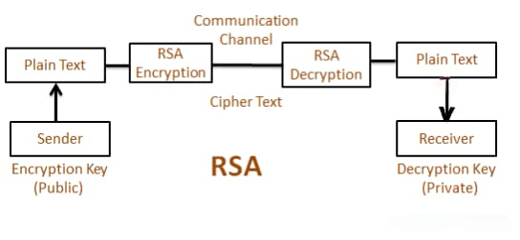

Fig 4.1 : Data flow diagram of RSA Algorithm

This simplified flowchart of the RSA encryption and decryption process, illustrating how plaintext is secured during communication between a sender and a receiver. Here's a detailed explanation of the components:

1. Sender

The process begins with the sender, who wishes to transmit a message securely.

Plain Text:
The original message or data in readable form (e.g., "Hello, RSA!") that the sender wants to send.

Encryption Key (Public):
The sender uses the recipient's public key (e, n) for encryption. This key is publicly available and ensures that only the intended recipient can decrypt the message.

2. RSA Encryption

The RSA encryption process converts the plaintext into ciphertext:

- The sender applies the recipient's public key to the plaintext using the RSA encryption formula:

C \equivM^e \ (\text{mod} \ n)

- M: Plaintext message converted into a numerical form.

- e: Public exponent.

- n: Modulus calculated from the product of two large prime numbers.

- Output: The result is the ciphertext (C), which is a scrambled version of the original message. This ciphertext is unintelligible to anyone who intercepts it.

3. Communication Channel

The encrypted ciphertext is transmitted over the communication channel to the recipient.

- The channel might be secure or insecure, but the ciphertext remains protected because only the private key can decrypt it.

4. RSA Decryption

The recipient receives the ciphertext and decrypts it using their private key (d, n):

- The RSA decryption formula is:

M \equivC^d \ (\text{mod} \ n)

- C: Ciphertext received.

- d: Private exponent.
- n: Modulus.

- The decryption process reverses the encryption, recovering the original plaintext message.

5. Receiver

The recipient, after decrypting the ciphertext, retrieves the original plaintext:

Plain Text:
The original readable message is restored and can now be understood by the recipient.

Decryption Key (Private):
Only the recipient’s private key, known exclusively to them, can decrypt the message. This ensures confidentiality.

Summary

- The sender encrypts the plaintext using the public key of the receiver.

- The ciphertext is transmitted securely, even over an insecure channel.

- The receiver decrypts the ciphertext using their private key to obtain the original plaintext.

This process ensures secure communication, where only the intended recipient can decrypt and access the original message.

CHAPTER 5

TESTING-TEST CASES

Testing RSA Algorithm: Test Cases

When testing the RSA algorithm, it's crucial to validate each step in the encryption, decryption, and key generation processes. Below are test cases designed to ensure that the RSA algorithm functions correctly under different scenarios.

1. Key Generation Tests

Case 1: Basic Key Generation

- Input: Select p=61, q=53, public exponent e=17.

Expected Output:

- Modulus
n = 61*53 = 3233.
- I(n) = (61-1) * (53-1) =3120

- Private key d= e^-1 (mod I(n)) =3120 .

- Public key: (e,n) = (17,3233).

- Private key: (d,n) = (2753, 3233) .

2. Encryption Tests

Case 2: Encrypt a Message

Input:
- Message: M=42 .

- Public key: (e,n) = (17,3233).

Process: Calculate ciphertext using C= M^e (mod n) .

Expected Output: C=42^17 (mod 3233).

3. Decryption Tests

Case 3: Decrypt a Ciphertext

Input:

- Ciphertext:C= 2557 .

- Private key: (d,n) = (2753, 3233).

Process: Calculate plaintext using M= C^d (mod n).

Expected Output:

M= 2557^2753 (mod3233)=42.

4. End-to-End Tests

Case 4: Encrypt and Decrypt a Plaintext

Input:

- Message: "HELLO".

Public key: (e,n) = ( 17,3233).

Private key:(d,n) = (2753,3233) .

Process:

1. Convert "HELLO" to its numeric representation (e.g., ASCII codes: HELLO -> 72, 69, 76, 76, 79).

2. Encrypt each number using C=Me (mod n) .

3. Decrypt ciphertext using M=Cd(mod n) .

4. Convert numeric values back to characters.

- Expected Output: Decrypted message is "HELLO".

5. Edge Case Tests

Case 5: Plaintext Exceeds Modulus

- Input: M= 4000 , n = 3233 .

- Expected Output: Encryption fails because M >n . RSA requires 0<=M<n

Case 6: Invalid Public Key

- Input:e=1 , I(n) =3210 .

- Expected Output: Public key generation fails because gcd(e,I(n) not equal.

Case 7: Decrypt Using Incorrect Private Key

Input:
- Ciphertext: C=2557 .
- Incorrect private key: (d,n)=(1234, 3233) .

Expected Output: Decryption produces incorrect plaintext.

6. Performance Tests

Case 8: Encrypt Large Messages

- Input: A message consisting of 1000 characters.

- Expected Output: Encryption and decryption complete without errors, and the original message is recovered.

Case 9: Large Key Sizes

- Input: Use 2048-bit keys.

- Expected Output: Key generation, encryption, and decryption are successful, though with increased computational time compared to smaller keys.

7. Security Tests

Case 10: Validate Confidentiality

- Input: Intercept ciphertext during transmission.

- Expected Output: The plaintext cannot be determined without the private key, ensuring confidentiality.

Case 11: Check Against Common Attacks

- Input: Simulate factorization attacks (attempt to factor ).

- Expected Output: The large prime factors and are computationally infeasible to find for key sizes ≥ 2048 bits.

Summary

These test cases cover functional, edge, performance, and security aspects of RSA. They help ensure the implementation is robust, efficient, and secure under various scenarios.

CHAPTER 6
RESULTS
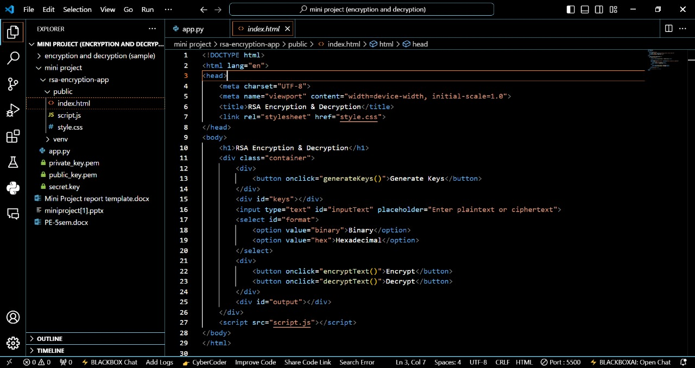
Fig 6.1 : HTML Code of encryption and decryption using RSA Algorithm

OUTPUT :
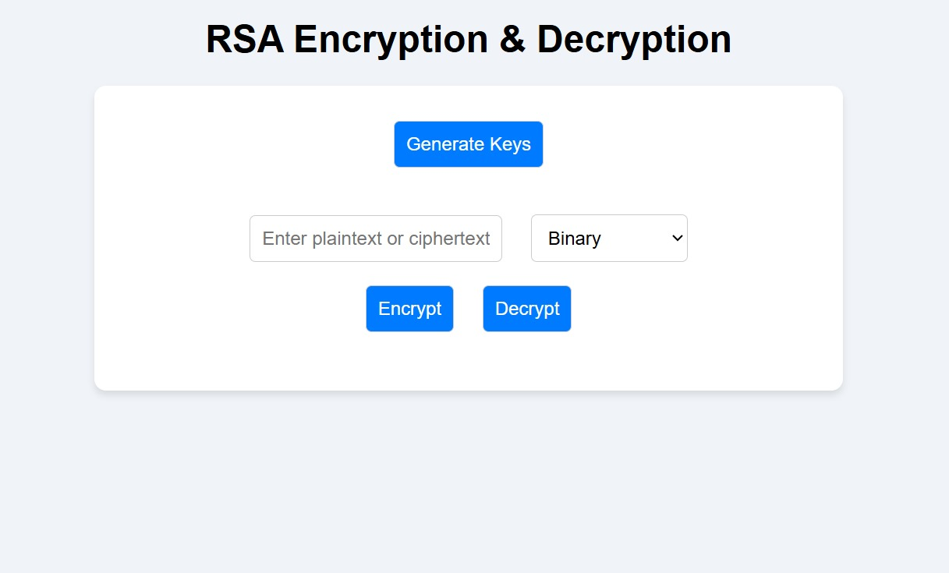
Fig 6.2 : Resultant View of RSA Encryption & Decryption

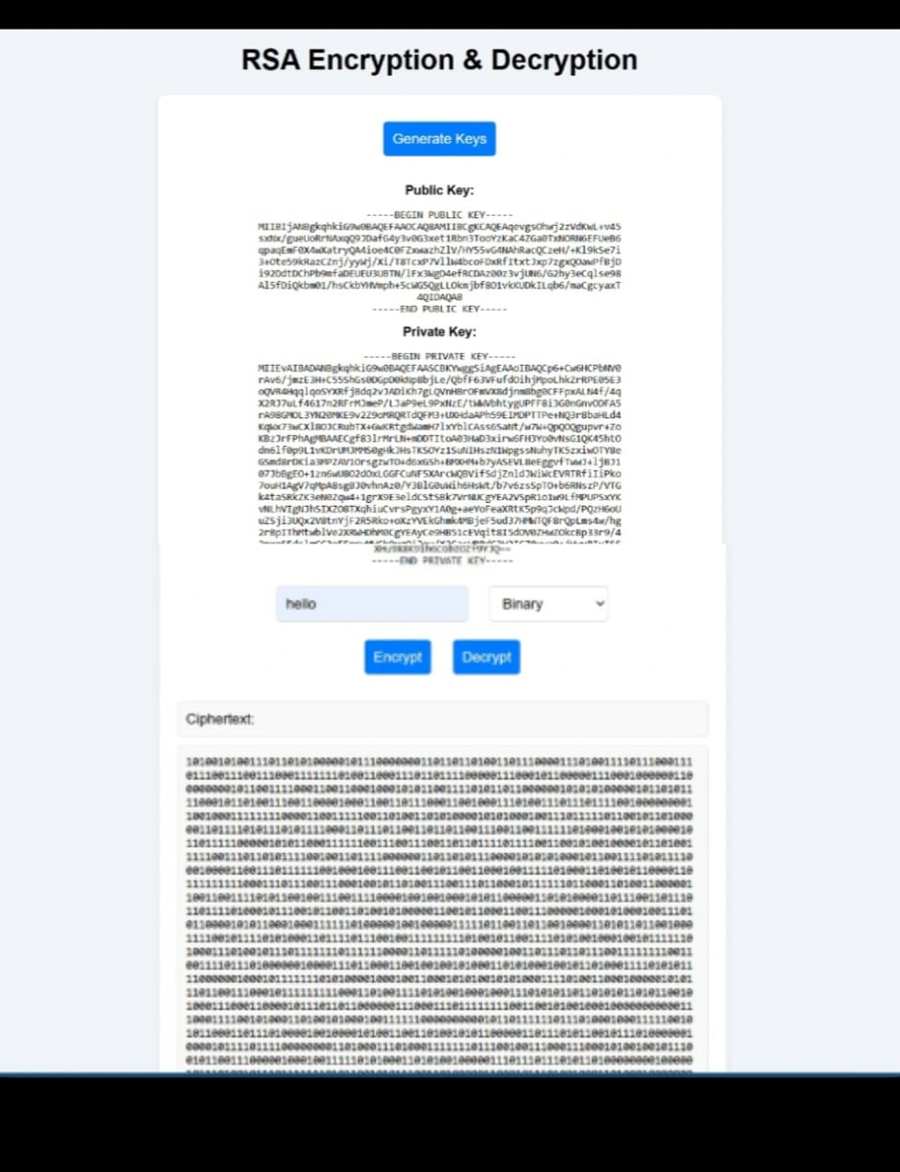
Fig 6.3 : When We Encrypt the Data using RSA Algorithm
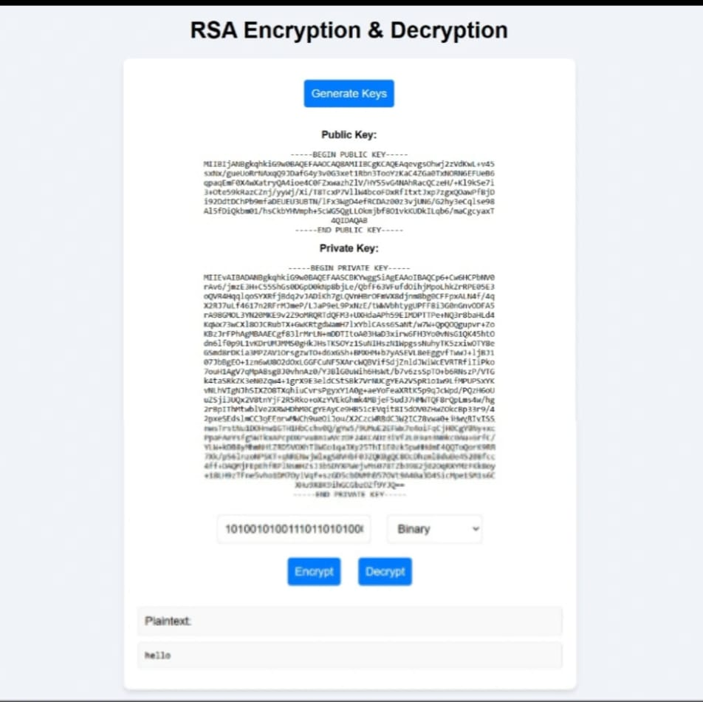
Fig 6.4 : When We Decrypt the Data using RSA Algorithm

CHAPTER 7

CONCLUSION AND SCOPE FOR FUTURE WORK

7.1 Summary Of Contributions

The RSA algorithm, developed by Ron Rivest, Adi Shamir, and Leonard Adleman in 1977, is a foundational cryptographic method in modern secure communication systems. Its contributions are summarized as follows:

1. Revolutionized Cryptography

- RSA introduced asymmetric cryptography, where separate keys (public and private) are used for encryption and decryption.

- It eliminated the need for secure key exchange in symmetric encryption, paving the way for scalable and secure communication over the internet.

2. Secure Data Transmission

- RSA ensures the confidentiality of data by enabling encryption using the public key, which can only be decrypted with the private key.

- It protects sensitive data during transmission, even over untrusted networks.

3. Digital Signatures

RSA enabled the concept of digital signatures, which verify:

- Authenticity: The sender’s identity.

- Integrity: The message hasn’t been tampered with.

- Non-repudiation: The sender cannot deny sending the message.
This functionality is critical in secure transactions, e-commerce, and software verification.

4. Key Exchange and Secure Communication

- RSA is widely used in protocols like TLS/SSL for secure web browsing.

- It ensures the secure exchange of symmetric keys, which are then used for faster encryption methods in hybrid systems.

5. Basis for Digital Certificates

- RSA supports the infrastructure of digital certificates and Public Key Infrastructure (PKI), enabling trust in web communication through authentication and encryption.

6. Enduring Security

- RSA relies on the computational difficulty of factoring large numbers (modulus ) into their prime components, a problem still computationally infeasible for sufficiently large key sizes (2048+ bits).

- It remains one of the most widely trusted cryptographic algorithms.

7. Applications Across Industries

RSA is used in:

- Banking and Finance: Securing online transactions and payments.

- Government: Protecting classified communications.

- Healthcare: Safeguarding electronic health records.

- Cryptocurrencies and Blockchain: Verifying transactions and identities.

8. Inspiration for Future Cryptography

- RSA’s success has inspired advancements in cryptographic research, including:

- Improved key generation techniques.

- Advanced cryptographic algorithms for post-quantum security.

The RSA algorithm has become a cornerstone of modern cryptography, offering secure, reliable, and scalable solutions for digital communication. Its principles continue to underpin many critical systems in our increasingly digital world.

7.2 Limitations and Scope for Improvements

- Limitations of the RSA Algorithm

Despite being a foundational and widely used cryptographic method, the RSA algorithm has certain limitations:

1. Computational Complexity

- RSA encryption and decryption involve modular exponentiation, which is computationally intensive, especially for large key sizes (e.g., 2048 or 4096 bits).

- This results in slower performance compared to symmetric key algorithms like AES, making it inefficient for encrypting large datasets.

2. Key Size Requirements

- RSA requires significantly larger key sizes (e.g., 2048 bits) to maintain security against modern computational power.

- Larger keys increase storage, processing time, and energy consumption, especially in resource-constrained environments like IoT devices.

3. Vulnerability to Quantum Computing

- RSA relies on the difficulty of factoring large numbers (the RSA problem). However, quantum computers using Shor’s algorithm can efficiently factorize large integers, breaking RSA's security.

- This makes RSA unsuitable for a post-quantum cryptographic environment.

4. Plaintext Restrictions

- The plaintext must be smaller than the modulus , which limits its use for direct encryption of large data without additional techniques like padding or splitting.

- Padding schemes (e.g., OAEP) add complexity and are vulnerable to implementation errors.

5. Susceptibility to Certain Attacks

- Chosen-Ciphertext Attacks (CCA): If padding schemes like OAEP are not implemented, RSA is vulnerable to attacks where adversaries manipulate ciphertext to deduce plaintext.

- Side-Channel Attacks: Attacks based on timing, power consumption, or electromagnetic leaks can reveal private keys if RSA implementations are not secured.

6. Lack of Forward Secrecy

- RSA lacks forward secrecy, meaning if a private key is compromised, all past encrypted communications can be decrypted.

- Modern protocols often combine RSA with ephemeral key exchange methods (e.g., Diffie-Hellman) to address this.

Scope for Improvement

1. Adoption of Post-Quantum Cryptography

Transitioning to post-quantum cryptographic algorithms, such as lattice-based or hash-based methods, can address vulnerabilities to quantum computers.

2. Use of Hybrid Encryption

Combine RSA with symmetric encryption algorithms:

- Use RSA for key exchange and AES for data encryption.

- This improves performance while leveraging RSA's secure key exchange.

3. Improved Padding Schemes

- Use robust padding schemes like Optimal Asymmetric Encryption Padding (OAEP) to protect against attacks like chosen-plaintext or chosen-ciphertext attacks.

4. Implement Forward Secrecy

- Incorporate forward secrecy by using ephemeral keys in conjunction with RSA in protocols like TLS.

5. Optimized Algorithms

- Employ optimizations such as the Chinese Remainder Theorem (CRT) to speed up RSA decryption.

- Research into faster modular arithmetic techniques can further enhance performance.

6. Enhanced Security Measures

- Protect against side-channel attacks by implementing constant-time algorithms or other countermeasures to minimize leaks during RSA operations.

7. Dynamic Key Sizes

- Dynamically adjust key sizes based on the required security level and computational capabilities to balance performance and security.

8. Key Management Systems

- Develop robust key management solutions to reduce the risks of private key compromise and ensure efficient revocation and renewal processes.

Conclusion

While RSA remains a trusted algorithm for secure communication, its limitations in performance, quantum vulnerability, and lack of forward secrecy demand attention. By adopting post-quantum methods, hybrid approaches, and enhanced security measures, RSA can evolve to meet the challenges of modern cryptographic needs.

BIBLIOGRAPHY

Below is a sample bibliography citing key references related to the RSA algorithm, cryptography, and its applications. You can modify or expand it based on your specific research sources.

Books

1. Stallings, W. (2016). Cryptography and Network Security: Principles and Practice. Pearson Education.

- A comprehensive guide covering cryptographic algorithms, including RSA, and their practical applications.

2. Menezes, A. J., van Oorschot, P. C., & Vanstone, S. A. (1996). Handbook of Applied Cryptography. CRC Press.

- A detailed reference book providing theoretical and practical insights into cryptographic techniques.

3. Schneier, B. (1996). Applied Cryptography: Protocols, Algorithms, and Source Code in C. John Wiley & Sons.

- Covers various cryptographic algorithms, including RSA, with practical implementations.

Research Papers

1. Rivest, R. L., Shamir, A., & Adleman, L. (1978). A Method for Obtaining Digital Signatures and Public-Key Cryptosystems. Communications of the ACM, 21(2), 120–126.

- The foundational paper introducing the RSA algorithm.

2. Boneh, D., & Shoup, V. (2020). A Graduate Course in Applied Cryptography. Draft Version.

- Provides advanced concepts on public-key cryptography and RSA.

3. Ghosh, A., & Sil, J. (2016). An Efficient Implementation of RSA Algorithm Using Modified Keys. International Journal of Computer Applications, 145(3), 1–6.

- Discusses RSA optimizations for enhanced performance.

Web Resources

1. RSA Security: Public-Key Cryptography Standards
RSA Laboratories. Retrieved from: https://www.rsa.com

- Official RSA documentation and resources.

2. NIST: Public Key Cryptography
National Institute of Standards and Technology. Retrieved from: https://www.nist.gov

- Guidelines on public-key cryptography, including RSA.

3. Khan Academy: RSA Encryption
Retrieved from: https://www.khanacademy.org

- A simplified educational resource explaining RSA encryption.

Standards

1. PKCS #1: RSA Cryptography Standard.
RSA Laboratories, Version 2.2 (2012).

- The official standard for implementing RSA encryption and digital signatures.

2. FIPS PUB 186-4: Digital Signature Standard (DSS).
National Institute of Standards and Technology (NIST), 2013.

- Provides standards for digital signatures, including RSA.

How to Format

- Follow the referencing style recommended for your work (e.g., APA, MLA, IEEE).

- Include specific links, journal names, or ISBN numbers when citing detailed sources.

RSA Algorithm using Encryption and Decryption

Dr.Chandrakala.H.L
Assistant professor
Dept. of Computer science and Design
BGSCET
Bangalore, India

Kiran kumar N.A
Dept. of Computer science and Design
BGSCET
Bangalore, India
1MP22CG026@bgscet.ac.in

Santhosh S.M
Dept. of Computer science and Design
BGSCET
Bangalore, India
1MP22CG048@bgscet.ac.in

Tharun K.L
Dept. of Computer science and Design
BGSCET
Bangalore, India
1MP22CG057@bgscet.ac.in

Jagadhish kumar N
Dept. of Computer science and Design
BGSCET
Bangalore, India
1MP23CG402@bgscet.ac.in

ABSTRACT

The Data Encryption and Decryption Tool employs a hybrid cryptographic approach using AES and RSA algorithms to secure sensitive data. AES (Advanced Encryption Standard) is used for fast and efficient encryption of large data sets like files and images, while RSA (Rivest-Shamir-Adleman) ensures secure keys exchange. The tool is specifically designed for applications such as file, text, and picture encryption and decryption, making it versatile for various industries. It supports multiple data formats, providing robust protection for documents, images, and text messages. With its intuitive interface, users can easily encrypt and decrypt data, ensuring high-level confidentiality. This is ideal for securing personal, corporate, or sensitive information, complying with data protection standards, and is suitable for fields such as finance, healthcare, and secure communications.

Keywords:

RSA Encryption and Decryption, HTML, CSS, JavaScript, Python and other Libraries

I.Introduction of RSA Algorithm

It introduced in 1977 by Ron Rivest, Adi Shamir, and Leonard Adleman, is a widely used asymmetric cryptographic algorithm. It employs two keys for encryption and decryption:

- Public Key: Used for encryption.
- Private Key: Used for decryption.

The security of RSA relies on the difficulty of factoring large composite numbers, which makes it computationally secure. The algorithm is rooted in number theory, involving prime numbers, modular arithmetic, and Euler’s Totient Function.

Steps in RSA Algorithm

- Key Generation

The key generation process involves creating a public-private key pair.

Step 1: Choose two large prime numbers, p and q:
- Select two random prime numbers p and q.
- These numbers should be kept secret.

Step 2: Compute n:
- Multiply p and q:
n=p×q
- n will be part of both the public and private keys.

Step 3: Compute Euler's Totient Function, ϕ(n):
- Calculateϕ(n) using formula:

ϕ(n)=(p−1)×(q−1)

- ϕ(n) represents the number of integers less than n that are coprime with n.

Step 4: Choose the public exponent e:
- Select e, which satisfies the following conditions:
  - 1<e<ϕ(n)
- Common choices for e are small prime numbers like 3, 17, or 65537.

Step 5: Compute the private key d:
- Calculate d as the modular multiplicative inverse of e modulo ϕ(n):
e×ϕ(n)=1e

- This means d satisfies:

d=e−1mod ϕ(n)d = e^{-1}

Step 6: Generate the keys:
- PublicKey:(e,n)
- Private Key: (d,n)This is kept secret.

- Encryption
This step uses the public key (e,n) to encrypt a message.

Step 1: Convert the plaintext message M into an integer m:
- Ensure mmm satisfies 0≤m<n0.
- If M is text, encode it (e.g., using ASCII or UTF-8) to convert it into an integer m.

Step 2: Compute the ciphertext C:
- Encrypt the message using the formula:C = m^e
- C is the encrypted message.

Step 3: Send the ciphertext C to the recipient.

3. Decryption
This step uses the private key (d,n)(d, n)(d,n) to decrypt the ciphertext.

Step 1: Compute the original message m:
- Use the formula: m=C^d

Step 2: Convert m back to plaintext M:
- Decode mmm (e.g., from ASCII or UTF-8) to retrieve the original plaintext message M.

Mathematical Basis of RSA

- Prime Numbers: Factoring the product of two large primes is computationally hard.
- Modular Arithmetic: Operations are performed over a modulus n.
- Euler’s Totient Function: Counts numbers coprime to n, fundamental for key generation.

II. Frontend Development

HTML , CSS and JavaScript
The frontend design of an RSA Encryption & Decryption tool. The explanation of how the frontend can be implemented using HTML, CSS, and JavaScript.

- HTML provides the structure of the page and defines elements like buttons, inputs, and layout.
- CSS is used to style the layout, buttons, inputs, and container to make the interface visually appealing.
- JavaScript adds functionality to the buttons (e.g., handling RSA key generation, encryption, and decryption processes).

Conclusion
The RSA algorithm is a robust and widely adopted cryptographic technique that ensures secure communication through asymmetric encryption. By utilizing a public key for encryption and a private key for decryption, RSA guarantees confidentiality, integrity, and authentication of data. Its security relies on the computational difficulty of factoring large composite numbers, making it an essential foundation for modern encryption systems.

Future Scope of RSA Encryption and Decryption

1.Continued Relevance in Secure Communications
- RSA remains a cornerstone in securing communications, including SSL/TLS protocols for web security.
- It will continue to be used for:
  - Secure email communication (e.g., PGP encryption).
  - Digital signatures to verify authenticity.
  - Certificate authorities for identity verification.

2. Adaptation for Emerging IoT and 5G Networks
- With the proliferation of the Internet of Things (IoT) and the global adoption of 5G, secure data transmission is crucial.
- RSA could be adapted for:
  - Authenticating IoT devices.
  - Enabling secure communication in edge and cloud computing.

3. Hybrid Encryption Models
- RSA is often combined with symmetric encryption algorithms (e.g., AES) in hybrid systems to balance security and performance.

- These hybrid models are expected to evolve, particularly for applications in large-scale secure data exchanges (e.g., healthcare, finance, and cloud storage).

4. Quantum-Resistant Cryptography
- The rise of quantum computing poses a significant threat to RSA due to algorithms like Shor’s, which can factor large numbers exponentially faster than classical computers.
- Future scope includes:
  - Transitioning RSA to higher key sizes (e.g., 4096-bit or greater) to counter immediate threats.
  - Phasing out RSA in favor of quantum-resistant algorithms (e.g., lattice-based cryptography).
  - Hybrid systems integrating RSA with post-quantum cryptographic techniques.

Challenges to Its Future
- Quantum computing advancements.
- Increasing key sizes leading to higher computational overhead.
- Adoption of more efficient, quantum-resistant algorithms

References

[1] Rongrong Xi, Shuyuan Jin, Xiaochun Yun and Yongzheng Zhang,“CNSSA: A Comprehensive Network Security Situation Awareness System”, in International Joint Conference of IEEE TrustCom, ISSN: 978-0-7695-4600-1/11,doi: 10.1109/TrustCom.2011.62, 2011.

[2] Wang, C. Yao, A. Singhal and S. Jajodia, “Network Security AnalysisUsingAttack Graphs :Interactive Analysis of Attack Graphs using Relational Queries”, in proceedings of IFIP WG Working Conference on Data and Application Security (DBSEC), 11.3 pages 119-132, 2006.

[3] Mr. Marc Grégoire and Mr. Luc Beaudoin, “Visualisation for Network Situational Awareness in Computer Network Defence”, in proceedings of visualisation and the common operational picture meeting RTO-MP-IST-043, Paper 20. 2008.

[4] White Paper on, “Public Safety and Homeland Security SituationalAwareness”, in ESRI, February 2008.

[5] P. Barford, M. Dacier, T. G. Dietterich, M. Fredrikson, “Cyber SA: Situational Awareness”, in Cyber Defense University of Wisconsin, 2009.

[6] Rostyslav Barabanov, Stewart Kowalski and Louise Yngström, “Information Security Metrics”, DSV Report series No 11-007, Mar 25, 2011

[7] Pallavi Vaidya and S. K. Shinde, “Application for Network Security Situation Awareness”, in International Conference in Recent Trends in Information Technology and Computer Science (ICRTITCS - 2012), IJCA, ISSN: 0975 – 8887, 2012.

[8] Xiu-Zhen Chena, Qing-Hua Zhenga, Xiao-Hong Guana,b, Chen-Guang Lina,Jie Sun, “Multiple behavior information fusion based quantitative threat evaluation”, in Elsevier Journal of Computers & Security , ISSN: 0167-4048 ,doi:10.1016/j.cose.2004.08.009,2005. pp 218-231

[9] Lingyu Wang, Tania Islam, Tao Long, Anoop Singhal, and Sushil Jajodia,“An Attack Graph-Based Probabilistic Security Metric”, in National Institute of
Standards and Technology Computer Security Division; Concordia Institute forInformation Systems Engineering, Montreal, Canada.

[10] Marianne Swanson, Nadya Bartol, John Sabato, Joan Hash, and LaurieGraffo, “Security Metrics Guide for Information Technology Systems”, in NISTSpecial Publication 800-55, July 2003.

[11] William Streilein, Kendra Kratkiewicz, Michael Sikorski, Keith Piwowarski, Seth Webster, “PANEMOTO: Network Visualization of Security Situational Awareness through Passive Analysis“, inWorkshop on Information Assurance United States Military Academy, Proceedings of the IEEE, 2007.

[12] Rongzhen FAN, Mingkuai ZHOU, “Network Security Awareness andTracking Method by GT”, in Journal of Computational Information Systems, Binary Information Press, ISSN: 1043-1050, Vol. 9: Issue 3, 2013.

